
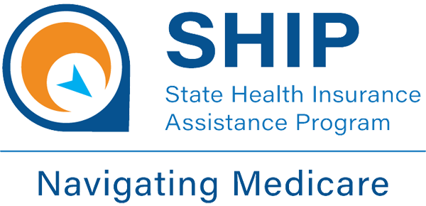

2026-2027 Medicare SHIP Site List by County
State Health Insurance Assistance Program
Local Medicare Help
Trusted, unbiased, one-on-one counseling and assistance
https://insurance.ohio.gov/about-us/divisions/oshiip

North Region – Darke County:

Ohio Senior Health Insurance Information Program (OSHIIP) 50 W Town Street Suite 300, Fl Third

Columbus, Ohio 43215 (800) 686-1578 website: https://insurance.ohio.gov/home

South Region – Preble County:

Ohio Senior Health Insurance Information Program (OSHIIP) 50 W Town Street Suite 300, Fl Third

Columbus, Ohio 43215 (800) 686-1578 website: https:// insurance.ohio.gov/home

