
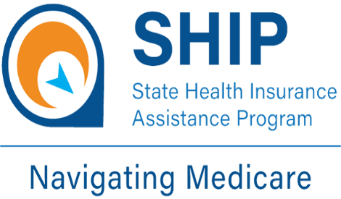
2026-2027 Medicare SHIP Site List by County
State Health Insurance Assistance Program
Local Medicare Help
Trusted, unbiased, one-on-one counseling and assistance

https://www.in.gov/ship/find-an-indiana-ship-location

(Area 6) Fayette County
Life Stream Services Inc. 1701 S Pilgrim Blvd Yorktown, IN 47396 (800) 589-1121 website: https://lifestreaminc.org
Neighborhood Health Center (Fayette County Medical Center) 2025 Virginia Ave Connersville, IN 47331 (765) 827-8064 website: https://www.neighborhoodhc.org/
SHIP Counselor- EC-Terri Hamm 1600 S. 2nd St. Richmond, IN 47374 (765) 914-5423 website: https://www.in.gov/ship/find-an-indiana-ship-location/
(Area 6) Franklin County
Life Stream Services Inc. 1701 S Pilgrim Blvd Yorktown, IN 47396 (800) 589-1121 website: https://lifestreaminc.org


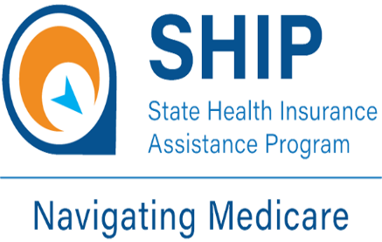
2026-2027 Medicare SHIP Site List by County
State Health Insurance Assistance Program
Local Medicare Help
Trusted, unbiased, one-on-one counseling and assistance
https://www.in.gov/ship/find-an-indiana-ship-location
(Area 6) Henry County
Life Stream Services Inc. 1701 S Pilgrim Blvd Yorktown, IN 47396 (800) 589-1121 website: https://lifestreaminc.org
Henry County Senior Center 108 S Main St New Castle IN 47362 (765)-521-7414 website: https://henrycountyseniorcenter.com/
(Area 6) Randolph County
Life Stream Services Inc. 1701 S Pilgrim Blvd Yorktown, IN 47396 (800) 589-1121 website: https://lifestreaminc.org
SHIP Counselor- EC-Terri Hamm 1600 S. 2nd St. Richmond, IN 47374 (765) 914-5423 website: https://www.in.gov/ship/find-an-indiana-ship-location/


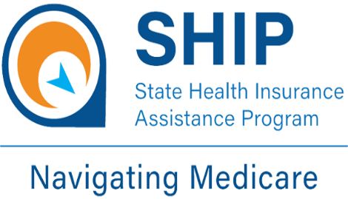
2026-2027 Medicare SHIP Site List by County
State Health Insurance Assistance Program
Local Medicare Help
Trusted, unbiased, one-on-one counseling and assistance
https://www.in.gov/ship/find-an-indiana-ship-location
(Area 6) Union County:
Life Stream Services Inc. 1701 S Pilgrim Blvd Yorktown, IN 47396- (800) 589-1121 website: https://lifestreaminc.org
Neighborhood Health Center (Union County Medical Center) 950 N Market Street Liberty IN 47353 (765) 458-5191 website: https://neighboorhoodhc.org
(Area 6) Wayne County
Life Stream Services Inc. 1701 S Pilgrim Blvd Yorktown, IN 47396- (800) 589-1121 website: https://lifestreaminc.org
Neighborhood Health Center 808 S A St Richmond, IN 47374 (765) 965-4299 website: https://neighboorhoodhc.org
Richmond Senior Center 1600 S 2nd St. Richmond, IN 47374 (765) 983-7300 website: https://www.facebook.com/p/Richmond-Senior-Recreation-Center-100063535808739/

2026-2027 Medicare SHIP Site List by County
State Health Insurance Assistance Program
Local Medicare Help
Trusted, unbiased, one-on-one counseling and assistance
https://www.in.gov/ship/find-an-indiana-ship-location
Area 6) Wayne County continued:
SHIP Counselor- EC-Terri Hamm 1600 S. 2nd St. Richmond, IN 47374 (765) 914-5423
website: https://www.in.gov/ship/find-an-indiana-ship-location/

Wayne Township Trustee 401 E Main St Richmond IN 47374 (765) 973-9392 website: https://waynetownship.org

